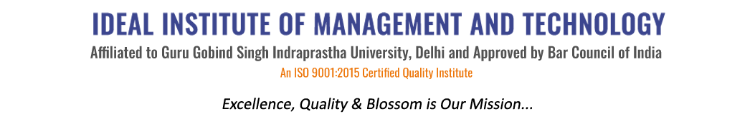
16 X, Karkardooma Institutional Area, (Near Telephone Exchange)
Delhi-110092
+91 (11) 22372639, 22375961,
http://idealinstitute.edu.in
Session 2013-2014-2015-2016-2017-2018
“INDUSTRIAL VISITS” (1st Shift)
Average percentage of student’s benefited by vocational Education and Training During 2013-2018
S.NO. | NAMES OF THE INDUSTRY | YEAR | No Of Students Attended VET
1 | MOTHER DAIRY | 20 , 21 Sep 2013 | 40+40=80
2 | VARUN BEVERAGES | 23 Aug 2014 | 40
3 | YAMAHA MOTORS, GREATER NOIDA | 21-4-15 | 40
4 | PARLE G | 25-08-15 | 42
5 | ANMOL | 26-08-15 | 47
6 | ANMOL | 27-08-15 | 47
7 | ORIENT BELL | 4-10-15 | 37
8 | MOTHER DAIRY | 20-10-15 | 31
9 | MOTHER DAIRY, PATPARGANJ | 30-10-15 | 31
10 | YAKULT, SONEPAT | 26-03-16 | 45
11 | BISLERI, SAHIBABAD | 23-02-16 | 58
12 | SRINATH JI ISPAT | 23-02-16 | 50
13 | VAROC, JAIPUR | 19-03-16 | 40
14 | ICD DELHI | 06-09-16 | 43
15 | HONDA, MANESAR | 08-10-16 | 40
16 | NDTV, DELHI | 21-10-2016 | 15
17 | DOORDARSHAN, DELHI | 06-02-17 | 45
18 | ICD ATTARI, AMRITSAR | 14-03-17 , 15-03-17 | 41
19 | NSIC, OKHLA, DELHI | 29-08-17 | 40
20 | MOON BEVERAGES | 26-09-17 | 39
21 | REVA TRANSMISSION, FARIDABAD, HARYANA | 24-01-18 | 40
22 | NITIN SPINNERS, BHILWADA, MEWAR | 12 -3-18 | 41

“INDUSTRIAL VISIT 2nd Shift)
S.NO. | NAMES OF THE INDUSTRY | YEAR | No Of Students Attended VET
1 | PARLE INDUSTRY | 24-8- 2015 | 42
2 | HINDWARE INDUSTRY | 25th- 26th August’ 2015 | 38, 42
3 | HELIOS PHARMACEUTICALS  (BADDI) | 6th- 7th November’ 2015 | 20
4 | MOTHER DAIRY | 16th- 17th November’ 2015 | 35,40
5 | BIG BASKET | 24-2- 2016 | 31
6 | AMAR UJALA | 14-3-2016 | 31
7 | HERO MOTOCORP | 19-8-2016 | 42
8 | SOMANY TILES | 8-9-2016 | 31
9 | MARUTI SUZUKI | 23-9-2016 | 31
10 | RELAXO | 27 -2- 2017 | 35
11 | PPAP | 22nd - 23st March’ 2017 | 29
12 | IMPERIAL MALT | 19 -8-2017 | 40
13 | IL & FS ENVIRONMENT INFRASTRUCTURE & SERVICES LTD | 28 -9-2017 | 30
14 | ALLIED NIPPON LIMITED | 27 -10-2017 | 40
15 | KAJARIA CERAMICS | 18 -1-2018 | 40
16 | UNIMAX SWITCH GEAR | 20 -2- 2018 | 42

